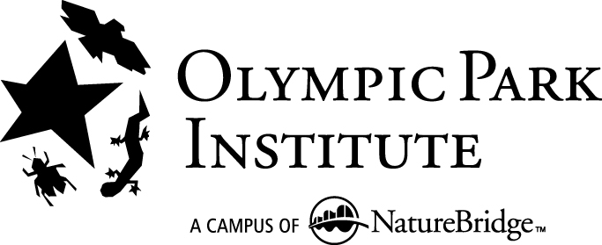

Administrative Assistant

Olympic Park Institute, a campus of NatureBridge

This is a full-time position at Olympic Park Institute, a campus of NatureBridge, located along the shore of Lake Crescent in Olympic National Park. Olympic Park Institute’s programs inspire a personal connection to the natural world and motivate students to become engaged citizens who address environmental issues that impact their local communities. NatureBridge, the largest educational partner of the National Park Service, currently has four campuses: Olympic Park Institute, Headlands Institute in Golden Gate National Recreation Area, Yosemite Institute in Yosemite National Park and Santa Monica Institute near Los Angeles. Each year, we serve more than 30,000 people from ethnically and economically diverse backgrounds through field science, youth leadership, family camps and teacher training programs.

Summary:

The Administrative Assistant serves as receptionist and provides administrative support to the Institute Director, campus administrative staff and National Office. The Administrative Assistant reports to the Facility Director.

Essential Duties and Responsibilities:
- Serve as receptionist and phone system operator.
- Serve as payroll and human resources secretary, supporting the national office.
- Support Institute Director and the Olympic Management Team, taking minutes at meetings, organizing action items and providing general administrative support.
- Manage the campus retail and petty cash operations.
- Assist staff in trouble shooting computer and network issues and serve as the campus liaison with the NatureBridge Information Technologies department.
- Manage campus office supplies and office equipment and their budgets.
- Process mail and incoming donations.
- Other duties as assigned

Qualifications
- Passion for the work and mission of Olympic Park Institute
- College degree and/or relevant experience
- 1year minimum professional office experience
- Well-organized and self-directed
- Strong computer skills, experience with Microsoft office, experience with computer hardware and networks
- Sound technical skills, experience with office equipment and procedures, analytical ability, good judgment, energetic and forward-thinking
- Ability to perform physical tasks such as setting up and moving office equipment, handling retail stock and performing other moderate physical duties.
- Ability to communicate (both verbally and in writing) to diverse internal and external audiences
- Ability to occasionally work evenings and weekends.
- Excellent customer service skills
- Knowledge of the Western Washington region
- Valid drivers license with a good driving record
Compensation
Wage commensurate with experience. Olympic Park Institute is dedicated to providing a comprehensive benefits package, medical and dental benefits and more. This position does not include housing.

Application Process
Please submit resume to: OPAdminAssistant@naturebridge.org by 5 pm, Monday, March 14, 2011.

